**CAED**

**Lab#08**

**Task1**

Code:

n=randi(50,0);

a=input("Write a number");

if(a>50)

disp("Number is greater")

elseif(a==50)

disp("Number is equal")

else

disp("Number is smaller")

end

Output:

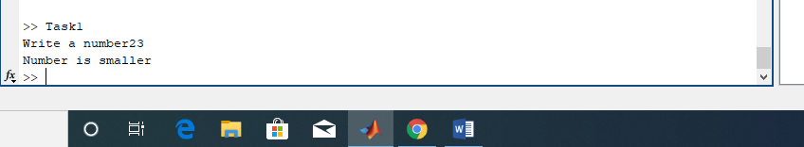

**Task2**

**Code:**

x=input("Write a number");

y=2*(x)+1;

y=2*(x);

if(x<5)

disp(y)

else

disp(y)

end

Output:

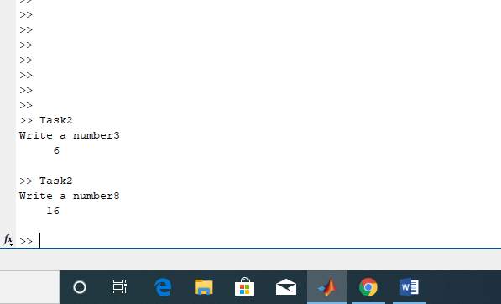

**Task3**

Code:

num=input("Write a max value");

for i=1:num

a=i^2;

disp(a)

end

Output:

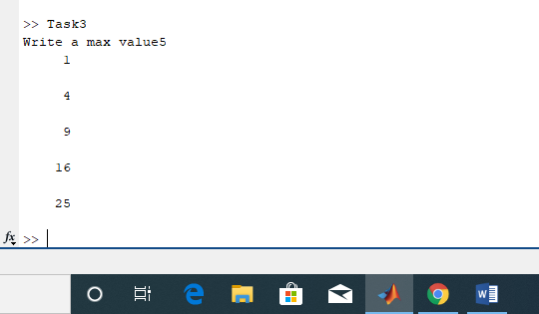

**Task4**

Code:

n=10;

fac=n;

while (n>1)

n=n-1;

fac=fac*n;

end

disp(fac)

Output:

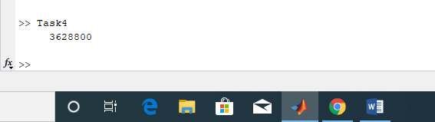

**Task5**

Code:

a=input("Enter 1st number");

b=input("Enter 2nd number");

c=input("Enter 3rd number");

if (a>b && a>c)

disp(a)

elseif (b>a && b>c)

disp(b)

else

disp(c)

end

Output:

